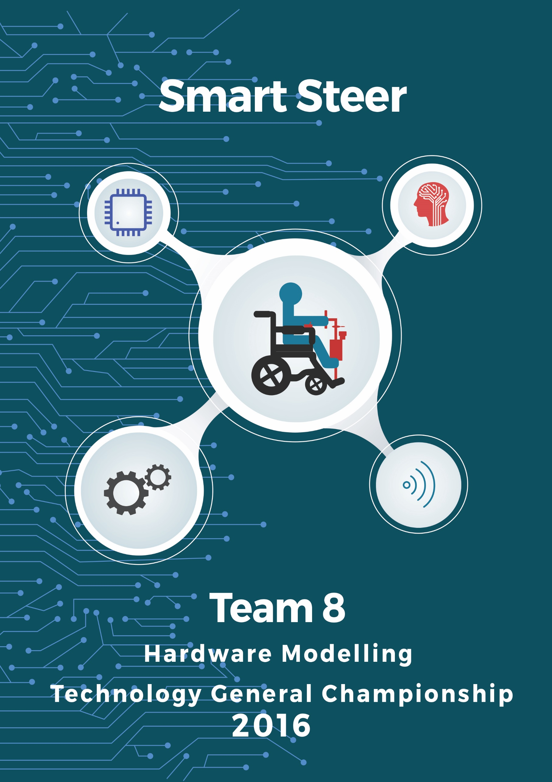

***INDEX***

1. **Introduction**
2. **Mechanical Design**
   1. **Steering**
   2. **Raising the front wheels of wheelchair**
   3. **Clutch Mechanism**
   4. **Brake by Wire**
   5. **Clamp**
3. **Embedded System and Software Architecture**
   1. **The Brain**
      1. **Raspberry Pi 2**
      2. **Arduino Mega 2560**
   2. **Drive Control System**
      1. **Brushless DC Hub Motor and Controller**
      2. **Digital to Analog Converter (DAC)**
      3. **Direction Control of Motor**
      4. **Modes of Operation**
   3. **Steer Control System**
      1. **Steer Motor and Motor Driver**
      2. **Autonomous Mode**
      3. **Joystick Mode**
   4. **Navigation System**
      1. **Rotary Potentiometer**
      2. **Inertial Measurement Unit and Magnetometer**
      3. **Obstacle Detection and Avoidance**
   5. **Wireless Control Box**
      1. **Nordic NRF24L01+**
      2. **Joystick Module**
   6. **Power Management System**
   7. **Complete Embedded Architecture and Circuit Schematic**
   8. **Image Processing using OpenCV and ROS**
      1. **Lane Detection and Tracking**
      2. **Obstacle Detection**
   9. **Android Application for Offline Bluetooth Voice Control**
4. **Cost Analysis**

***Introduction***

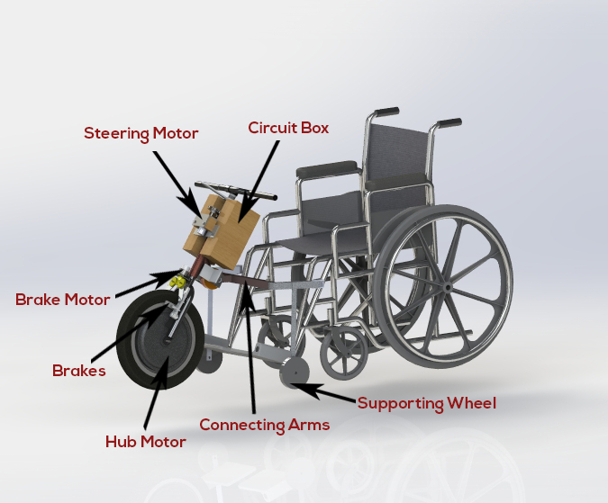Disability of any nature presents challenges in one's life but doesn't necessarily mean that life with a disability can't be fulfilling. One should have control over their daily activities and should be able to choose how they want to live. Many people from birth or due to a traumatic accident are forced to live the entirety of their life on a wheelchair. Though it provides them with the freedom to move it also has many restrictions. It is very useful to travel indoors to accomplish daily activities but becomes extremely strenuous to travel long distances. To achieve that one often uses a hand tricycle or an electric wheelchair. Though the later solves most of the issues it comes at a very high price due to two Brushless DC servo motors, which is not affordable by all. A hand tricycle is very cheap and affordable but requires a lot of effort to ride it. Also it does not provide full autonomy as they may require help in transitioning from one vehicle to another.

We essentially need a vehicle which can perform long commute like a hand tricycle but also small enough to be ridden indoors. In this report we propose an easily attachable steering (with a wheel) to the wheelchair for long commute. The steering comes equipped with a Brushless DC servo motor to drive the wheelchair with built in smart features like autonomous lane detection and tracking, obstacle avoidance etc. The design also provides an optional steering assist feature to steer by wire, an additional electric brake for brake by wire. To target various disabilities we have used a wireless controller for partial hand-based disability, voice controlled and autonomous mode for fully disabled.

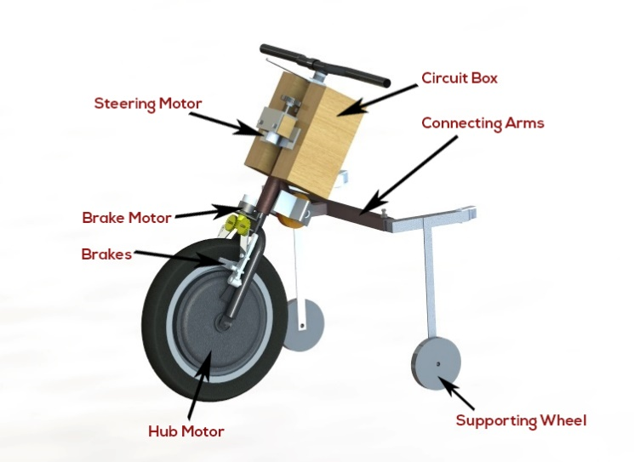***Mechanical Design***

Our detachable steering has a front wheel which has a brushless DC hub motor to allow forward locomotion. The steering comes with a pair of connecting arms which rigidly attaches the steering to the wheelchair. The distance between the arms can be varied depending on the width of the wheelchair. The braking system utilizes both manual braking and brake by wire using V-brakes. One of the key smart features of the steering is that it can be used in manual mode, interactive mode and in autonomous mode. In the manual mode the hand brakes are used, while in the autonomous mode the automatic brakes comes into play which are operated with the help of a dc motor and a worm gear mechanism to achieve high reduction in RPM in small space. Similarly the steering is also achieved manually and steer by wire. The manual steering gives the user complete freedom and comfort of driving, for the users who find it difficult to steer or require steering assistance, the wheelchair can rely on steer by wire

Present wheelchair modifications for long distance commuting involve a single handle for steering and a pair of hand pedal for locomotion. However the use of this vehicle is only restricted to outdoors as it is larger than the wheelchair, and thus requires switching from the wheelchair whenever a long distance travel is required. Also people with partial paralysis require a dedicated servant to switch between vehicles. Thus there is a need of a vehicle which can be used for both small and long distance travel. To solve this issue rather than moving the person from one vehicle to another we decided to add a steering mechanism to the wheelchair when long distance travel may arise.

***Easily Attachable***  
Wheelchair with a fixed steering cannot be used in indoor and thus there is a need to have an attachable steering mechanism which requires minimum effort from the user to convert his/her wheelchair for long distance commuting and can be easily attached to any existing wheelchair with no modifications required to the wheelchairs. Thus one steering mechanism can be used by multiple users in places like trauma centers and accident hospitals where they can be attached to any wheelchair as per their needs.

***Three wheel contact***   
With a steering being added the problem is that the wheelchair would become a five wheeled vehicle. This will prove to be disadvantageous when using the wheelchair in roads with speed breakers or a rough road with pebbles. Five wheel contact is unfavourable as not all the wheels can be in contact with the road, which may lead to loss of contact of the drive wheel moreover it might get stuck in an uneven road or at speed-breakers. There arises a need to break the contact of the two small wheels attached to the front of the wheelchair from the ground. The whole vehicle becomes three wheeled. This has many advantages. Firstly a three wheeled vehicle has superior responsiveness as compared to a four wheeler due to its rapid yaw response time. A single front wheel vehicle has a natural oversteering tendency thus allowing the user to perform extreme maneuvers.

***Adjustable Arm span***  
Wheelchairs come in different sizes and according to a report by the Bureau of Indian Standards, wheelchair widths vary from less than 55.cm to 70 cm. Since our attachable steering design needs to adaptable to all wheelchairs, it requires that the arms used to connect the steering to the wheelchairs should be able to adjust to the width of the wheelchair. Thus with the help of a sliding joint which can be fixed as per the wheelchair width requirements is present in our design

***Steering***

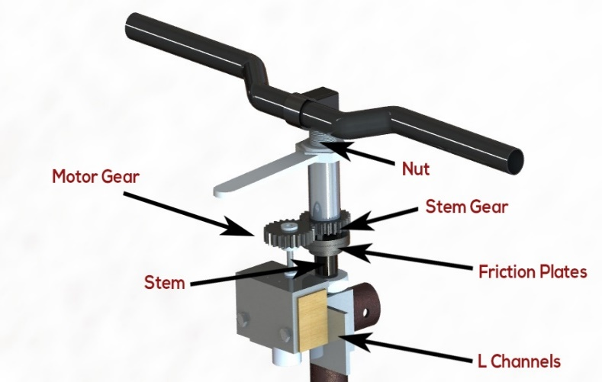The steering mechanism needs to have both steer by wire and manual steering based on the requirements of the user. Thus there arises the need to be able to switch between steer by wire and manual steering. This is done so that in the manual steering mode there is no extra effort required to turn the steering against the motor. Also turning against the motor could damage the gear box inside the motor.

The mechanism involves the following:

The motor is mounted onto L-channels which are rigidly fixed to the steering. The motor has a gear attached to its shaft which transmits torque to another gear which is free to rotate on the stem of the steering. In partial contact with the gear is a friction plate which is rigidly attached to the stem of the steering.

Switching between manual steering and steer by wire is achieved by engagement of the friction plates. The gear attached to the steering, has a friction plate rigidly attached to one of its faces which is in partial contact with the other friction plate.

In order to generate enough friction between the friction plates, a nut is attached to the stem of the steering, which on turning an angle more than 90 degrees presses against the gear which is free to rotate. This brings the 2 friction plates in contact with each other, allowing no relative motion between them. Now the steering mechanism can be operated autonomously without much loss in transmission.

When one needs to switch to the manual mode, turning the nut in the opposite direction breaks the contact between the friction plates and allows the user to turn the handle with minimum effort without the fear of damaging the motor.

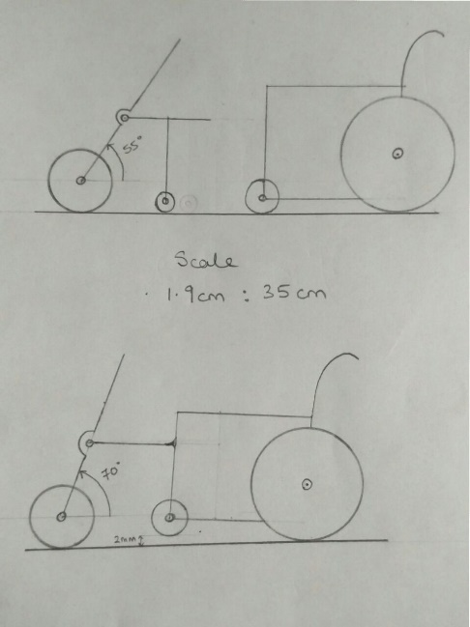***Raising the Front Wheels of Wheelchair***

The attachment approaches the wheelchair with the stem making an angle of 35 degrees from the vertical. The connecting arms are attached to the wheelchair, and the handle is pushed in forward direction while pressing the clutch, so that the angle of stem changes to 10 - 15 degrees from the vertical, and breaking the contact between the front wheels of the wheelchair to raise them around 4 cm above the ground level. When the clutch plates are not in contact they allow relative angular motion of the connecting arms with respect to the stem. As soon as the clutch is released this relative angular motion is restricted, hence maintaining the orientation of the wheelchair without any need of external force.

***Clutch Mechanism***

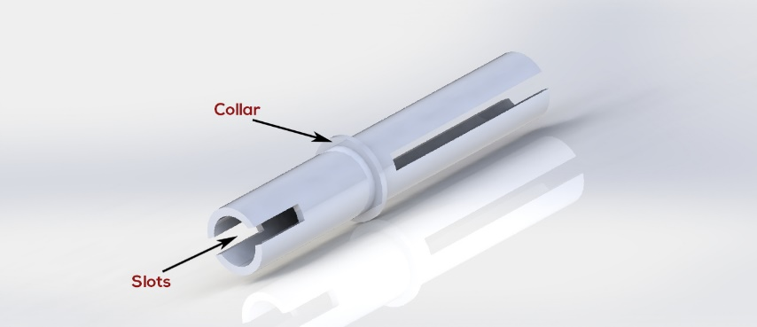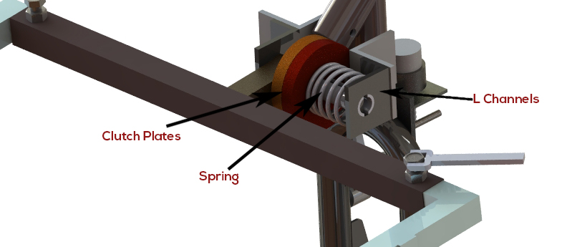The 80mm diameter clutch plates are mounted on a 130mm shaft, the shaft is connected to the L plates which are rigidly fixed to the stem. The shaft is slotted from both the sides and can be fixed to L plates with the help of pins, so that there is no angular motion of the shaft. One of the clutch plates is fixed on a collar at 53mm from one end of the shaft, the other clutch plate can move along the slot made on the shaft. In normal condition the clutch plates are pressed against each other by a spring restraining any relative motion of the plates. When the clutch is pressed the spring is compressed and the plates are separated by 1mm, allowing the relative motion between these plates.

***Brake by Wire***

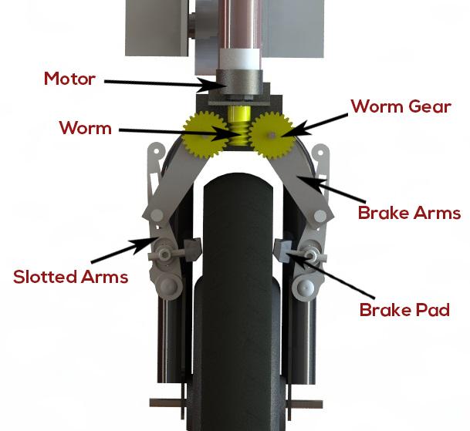When in autonomous mode, the wheelchair needs to have a braking mechanism, as avoiding obstacles is not always a safe option. This is achieved with the help of a worm gear mechanism. This is done because the worm gear provides large speed reduction ratio (subsequently higher torque) in a restricted space. The worm gear used in our design has a ratio of 25:1.

The motor mount is rigidly attached to the fork of the steering with the worm at the centre and two worm gears at each side. There are brake arms fixed to each worm gear, which have a pin fixed at its ends. Attached to the fork are the long slotted arms with the brake pad of a manual power brake. The pin slides over the long slotted arm moving the brake pad to engage them.

When the motor is activated, the worm gear provide a speed reduction of 25. This in turn rotated the slotted arms attached to the fork with the help of the pin in a slot joint. Thus this brings the rubber pad in contact with the wheels and helps in braking. The long slotted arms provide mechanical advantage to the arms attached to the pinion thus requiring lesser torque to provide a larger braking power. Thus even a low torque motor can be used to stop the wheelchair in minimum time.

***Clamp***

The clamps in the attachable mechanism need to be easily attachable to the wheelchair and without making any modifications to the wheelchair. The clamp mechanism works in the following manner:

The movable arms of the mechanism have a revolute joint at its ends. These revolute joints are attached to the clamp which has a square cross section. The clamp has a square cross-section because this prevents any rotational motion between the clamp and its counterpart on the wheelchair and also has a larger second moment of area thus lesser bending stress.

The counterpart is attached to the frame of wheelchair with the help of a circular clamp which has a solid square cross section bar rigidly attached to its end. The circular clamp can be tightened onto the frame with the help of a screw and remains rigidly fixed to the frame with the help of friction. On attaching the arms of the steering mechanism to the counterpart on the wheelchair, a pin is inserted to hold it in place and make a rigid connection.

The width of the arms attached to the steering mechanism can be adjusted with the help of a sliding joint. This prismatic joint consists of a solid square bar rigidly attached/screwed to the arm containing the clamp. A square cross section is used for the same reasons, no relative motion and lesser bending stress. The sleeve in which this square bar slides has a screw attached to its top. When the width of the arms has been adjusted as per the requirements of the wheelchair, the user has to turn this screw, which holds the prismatic joint in place with the help of friction.

**Embedded System and Software architecture**

The mechanical model needs to be actuated properly and thus required electrical and electronic peripherals were added to complete the automation process. The complete Embedded System is divided into various parts described in detail as subsections.

***The Brain***

The model houses a Raspberry Pi 2 and an Arduino Mega 2560, which are responsible for efficiently operating the model in Autonomous Mode.

***Raspberry Pi 2***

The Raspberry Pi 2 is a [credit card](https://en.wikipedia.org/wiki/Credit_card)–sized [single-board computer](https://en.wikipedia.org/wiki/Single-board_computer) powered by ARM Cortex A7 processor. It has the following specifications: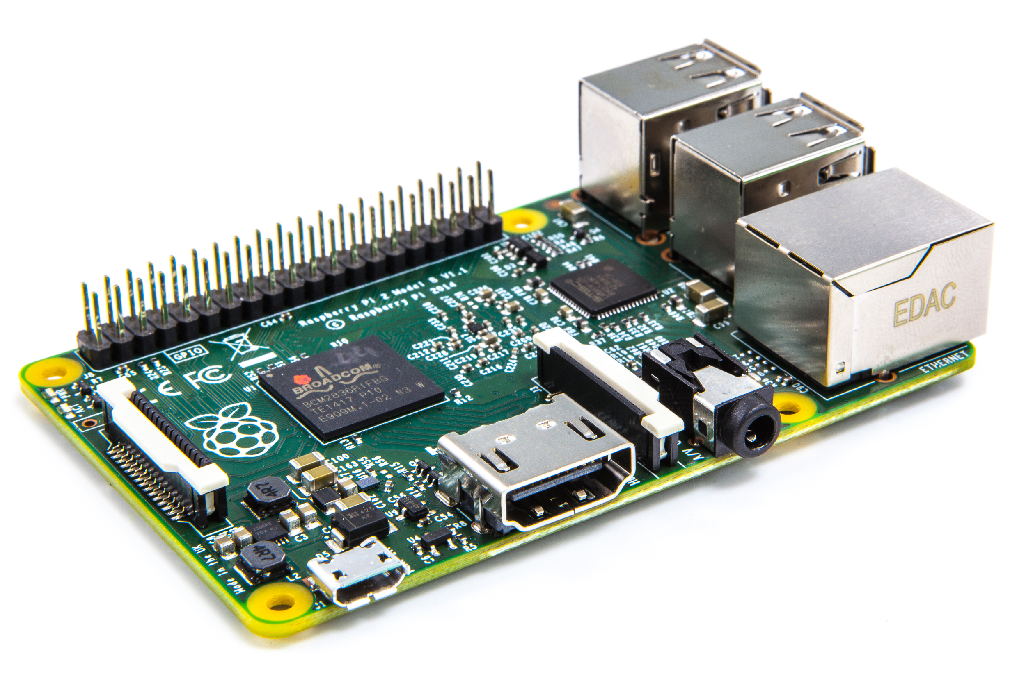

* A 900MHz quad-core 32-bit ARM Cortex-A7 CPU
* 1GB RAM
* 4 USB ports and 40 GPIO pins
* Full HDMI port
* Ethernet port
* Combined 3.5mm audio jack and composite video
* Camera interface (CSI)
* Display interface (DSI)
* Micro SD card slot
* Video-Core IV 3D graphics core

The Pi runs Robot Operating System (ROS) framework for getting data from sensors and generating outputs for the actuators

***Arduino Mega 2560***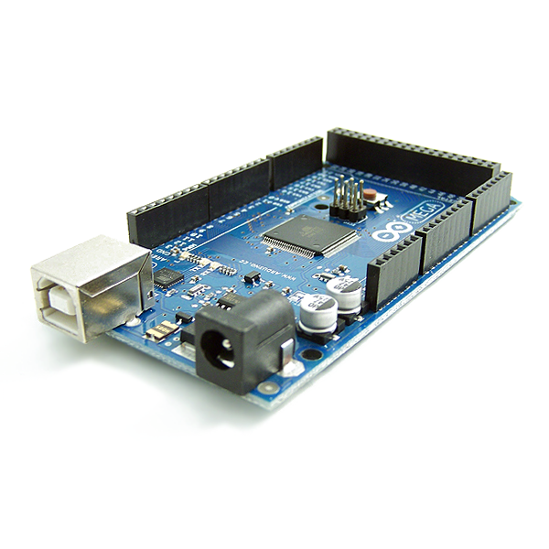

The Mega 2560 is a microcontroller board based on the [ATmega2560](http://www.atmel.com/Images/Atmel-2549-8-bit-AVR-Microcontroller-ATmega640-1280-1281-2560-2561_datasheet.pdf). It has 54 digital input/output pins (of which 15 can be used as PWM outputs), 16 analog inputs, 4 UARTs (hardware serial ports), a 16 MHz crystal oscillator, a USB connection, a power jack, an ICSP header, and a reset button.

It is used as a low-level controller in the system accomplishing the job of getting sensor data from various sensors using different protocols and outputting appropriate signals according to planner output received from the Pi to the drivers which actuate the motors.

***Drive Control System***

***Brushless DC Hub Motor and Controller***

The drive motor is a Brushless DC Hub motor operating at 24V, 350W. It is driven by a dedicated Motor Controller which has in-built control loop implemented for precise control 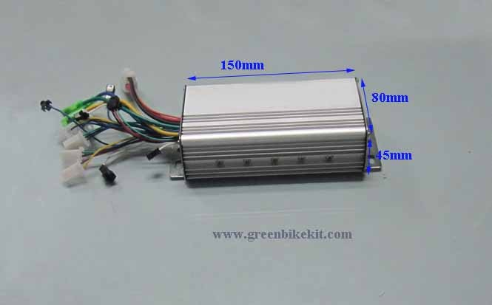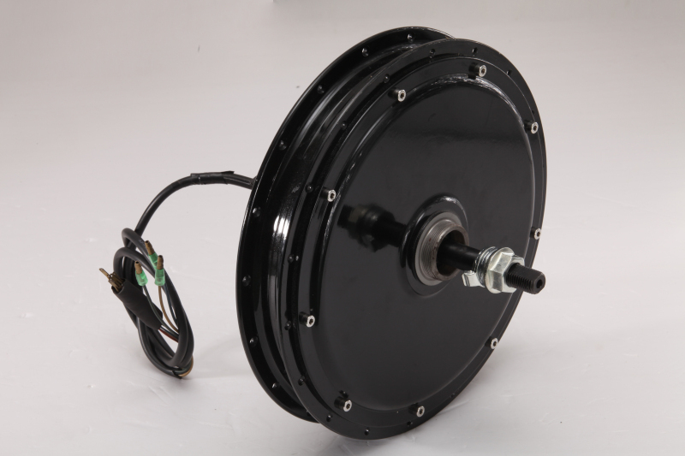over the motor speed. The controller incorporates Hall Sensor based commutation of the motor and takes an analog voltage for speed control. Direction control is not provided.

***Digital to Analog Converter (DAC)***

The analog voltage in the range 0-5V required by the motor controller is generated electronically by employing a DAC (Digital to Analog Converter) module with IC PCF8591.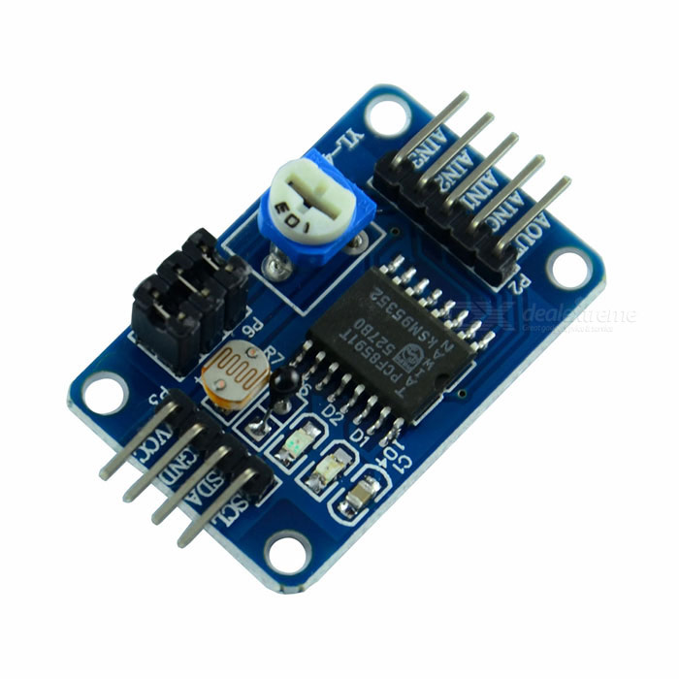

*Features:*

* Operating voltage range of 2.5V-6V
* 10-bit Digital to Analog Converter
* Works on Inter Integrated Circuit (I2C) protocol
* I2C address = 0x48

The DAC module gets data as 8-bit value from Arduino via I2C interface and the correspondingly converts it into an Analog voltage outputted at the analog output pin.

***Direction Control of Motor***

For our application forward as well as backward rotation of the BLDC motor is required and since this functionality is not provided by the motor controller, a separate circuit for switching direction of the motor is employed.

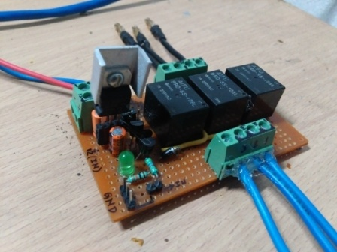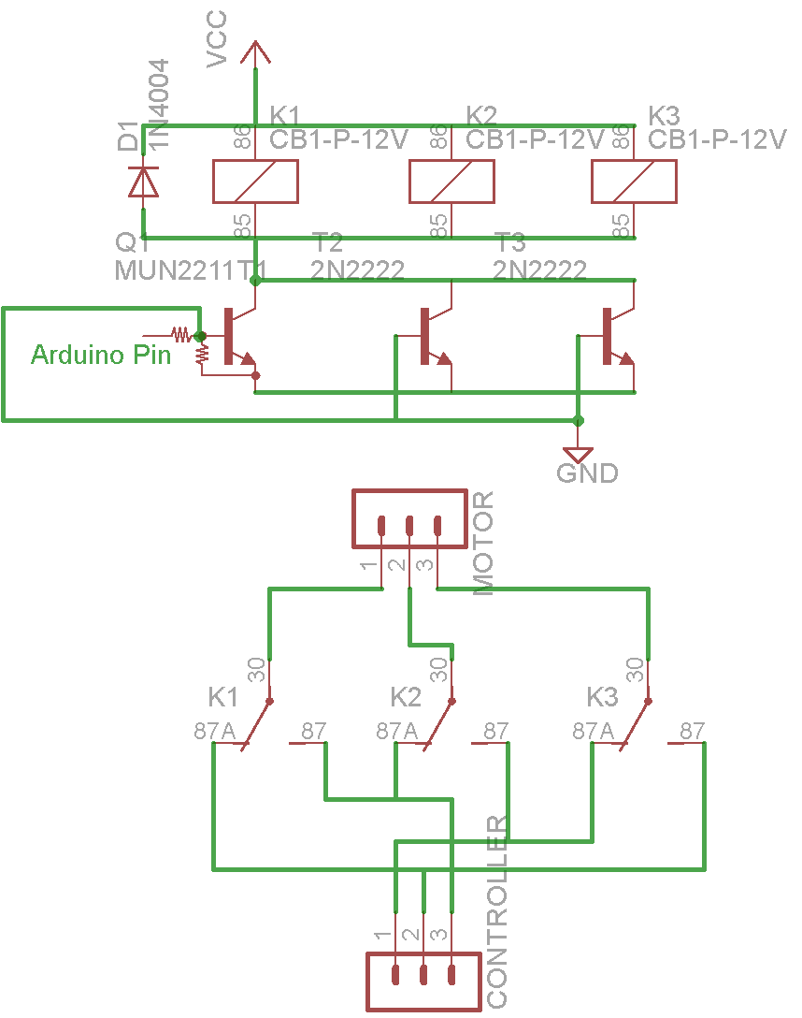The circuit works on the principle of switching the 3-motor wires in a prescribed manner between two pre-known states so as to achieve direction control. Three high-current relays with their coils controller by a BJT operating as a switch are used for the purpose of parallel switching the motor coils. The circuit schematic and the actual circuit are shown.

***Modes of Operation***

The drive supports 3 modes of operation namely:

1. *Manual Mode* - In this mode the steering is controlled manually and the drive motor is controlled by the accelerator on the handle.
2. *Interactive Mode* - In this mode Wireless Joystick Control and Bluetooth Voice Control of the model is achieved.
   1. Joystick Control - A wireless control box equipped with a joystick module is used to control the drive and steering.
   2. Bluetooth Voice Control - The model is controlled by offline voice recognition on an Android phone and communication using Bluetooth module.
3. *Autonomous Mode* - In this mode, the model moves autonomously at a slow speed employing Lane Detection, Path Planning and Obstacle avoidance

The switching between the modes is achieved by use of switches in the wireless control box.

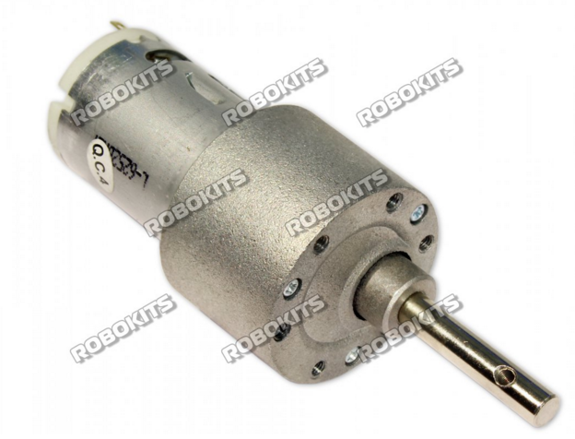

***Steer Control System***

***Steer Motor and Motor Driver***

The Steer Motor is a High-torque DC motor with the following specifications:

* 12V-18V operating voltage
* 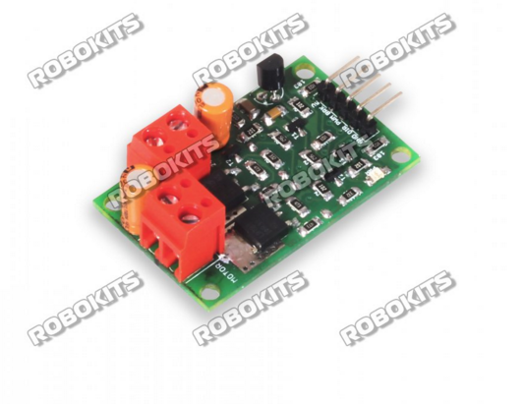Maximum torque output of 120 Kg-cm
* Maximum Load Current of 7.5A

The Motor is driven by a Dual-Half H-Bridge high current DC motor driver of following specifications:

* Compatible with motors rated 6V-18V
* Continuous output current of 20A
* Operates with PWM, BRAKE and DIR inputs. 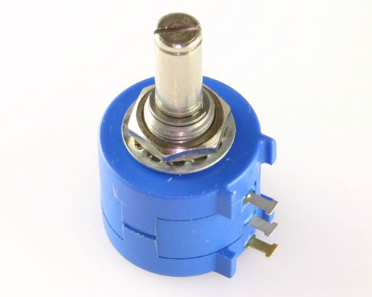

The steer motor is operated in a closed loop by taking angle feedback from a rotary potentiometer.

A PID controller is implemented in code to attain position control of the motor. The controller is tuned manually to obtain desired response.

Autonomous Mode

* Path planner dictates the handle angle using data from sonar and image processing.
* 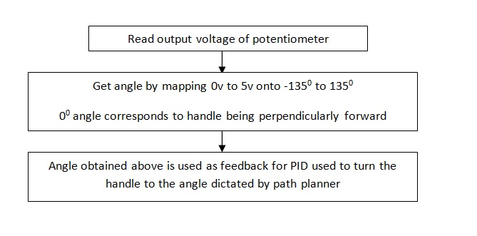A potentiometer with angle range of 2700 is attached to the handle which provides feedback to the PID controller.

Joystick Mode

* Joystick gives analog output in two axis X and Y with magnitude depending upon the extent to which it is bent.
* 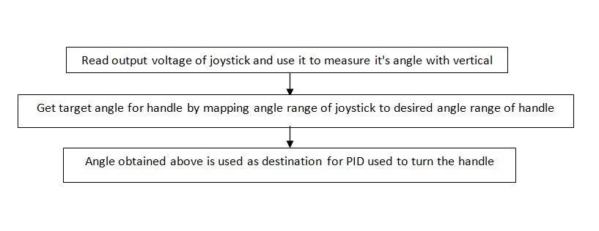The X axis is used to control drive motor and Y axis is used to control steer motor.

***Navigation System***

The navigation system incorporates sensors for detecting pose (orientation) of the model.

This data is then used as feedback to control the pose in the required manner.

The system involves the following sensors:

***Rotary Potentiometer***

It is attached to the handle shaft and gives the orientation of the handle with respect to the body. It outputs data in the form of analog signal in the range 0-5V which is processed using Analog to Digital converter (ADC).

***Inertial Measurement Unit (IMU) and Magnetometer***

A combination of IMU MPU-6050 and a magnetometer HMC5883L is used to obtain the global heading of the model.

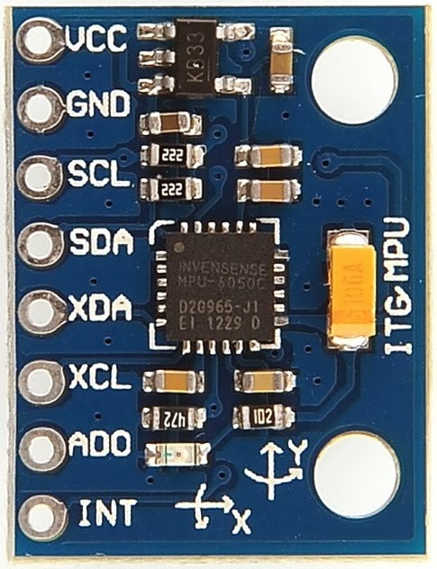

***MPU-6050***

MPU-6050 sensor contains a MEMS accelerometer and a MEMS gyro in a single chip.

* Very accurate.16-bits ADC hardware for each channel.
* Captures x, y, and z channel at the same time.
* Uses the I2C-bus to interface with the Arduino.
* I2C Address = 0x68 and 0x69

***HMC5883L***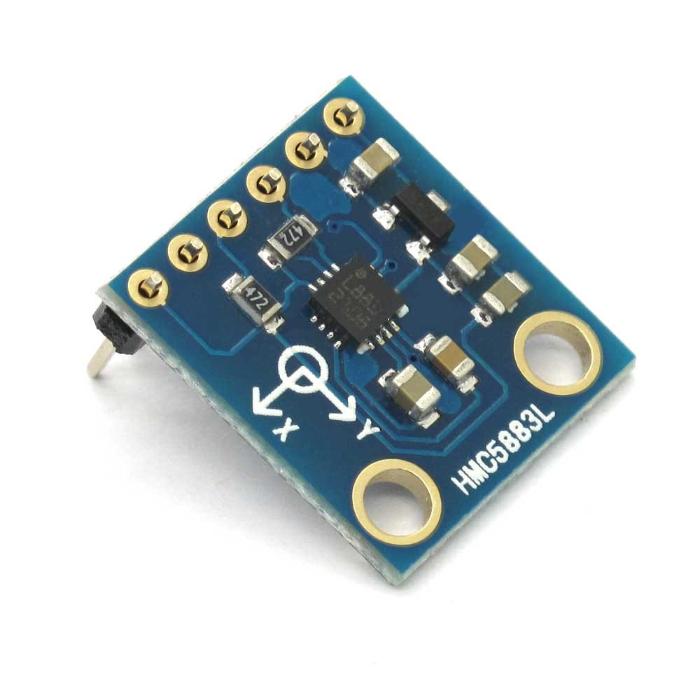

A 3-axis digital compass. Communication with the HMC5883L is simple and all done through an I2C interface.It has:

* 12-Bit ADC Coupled with Low Noise AMR Sensors Achieves 2 milli-gauss Field Resolution in ±8 Gauss Fields .
* Built-In Self Test
* Fast 160 Hz Maximum Output Rate
* I2C Address = 0x3D

The data from the IMU and Magnetometer are fused using a Complementary filter to obtain the final heading angle as described below.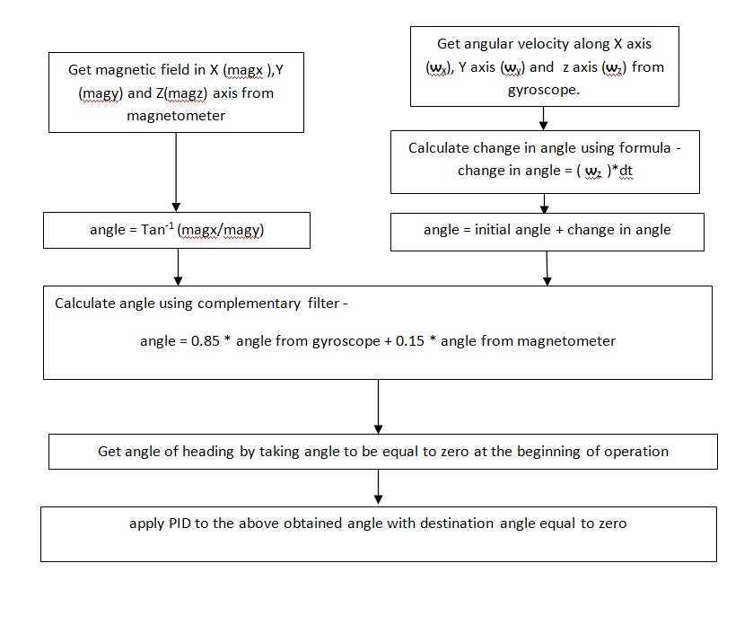

***Obstacle Detection and Avoidance***

For obstacle detection three Ultrasonic Sensors are used each pointing towards left, front and right respectively.

The time of flight of ultrasonic wave is determined and then this time information is used to calculate the distance to the obstacle.

Distance = ((Duration of high level)*(Speed of Sound))/2

***Ultrasonic Sensor HC-SR04***

* Ultrasonic sensor HC-SR04 provides distance measurement in the range 2cm-400cm.
* 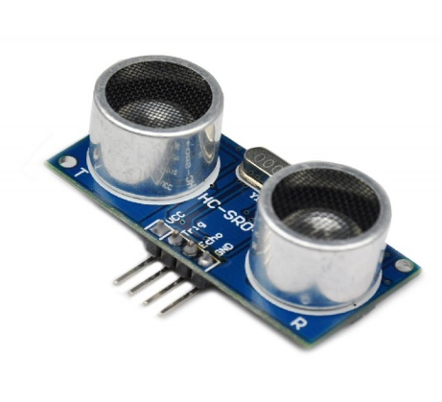 The ranging accuracy can reach to 3mm.
* The basic principle of work:
  + Using IO trigger for at least 10us high level signal,
  + The Module automatically sends eight 40 kHz and detect whether there is a pulse signal back.
  + If the signal back, through high level , time of high output IO duration is the time from sending ultrasonic to returning.

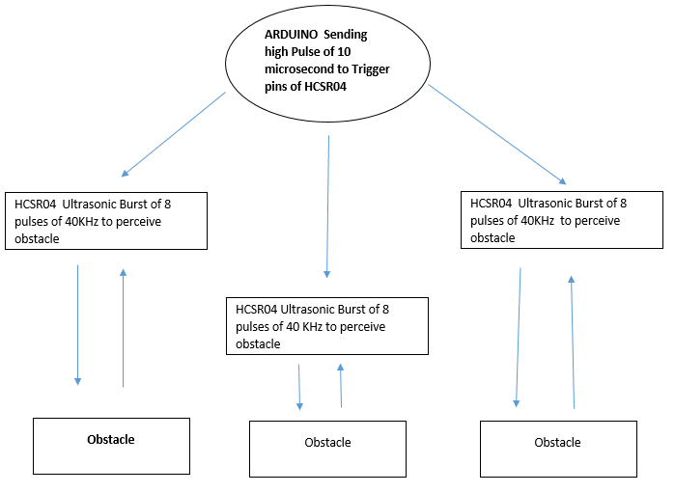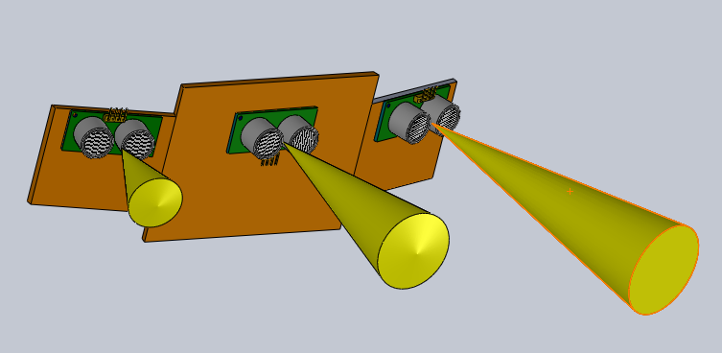

The output from the sonars is used to detect the position of the obstacle in front of the model and plan the path accordingly to avoid collision with it.

***Wireless Control Box***

The wireless control box is meant to provide the user convenience of operating the model.

The Manual mode is for people with only leg amputy in which they can use the handle accelerator to control the model at their will.

The Interactive mode features a Joystick Control mode for elderly people who are to be restricted from stretching muscles. The handy wireless control box provides a convenient method for them to control the model fully at the tip of their fingers.

The control box employs an Arduino Nano as its brain. It involves sensors and modules as listed below:

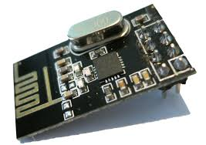

***Nordic NRF24L01+***

The Nordic nRF24L01+ integrates a complete 2.4GHz RF transceiver, RF synthesizer, and baseband logic including the Enhanced ShockBurst™ hardware protocol accelerator supporting a high-speed SPI interface for the application controller. The low-power short-range (50-200 feet or so) transceiver is available on a board with Arduino interface and built-in Antenna.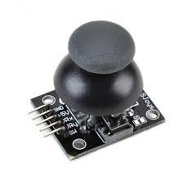

***Joystick Module***

The 2-Axis Joystick provides a simple and convenient way to add X-Y control to a project. A potentiometer attached to each axis provides proportional feedback of the up/down and left/right positions. The joystick is spring-loaded, so that it always returns to its centred position when you release it.

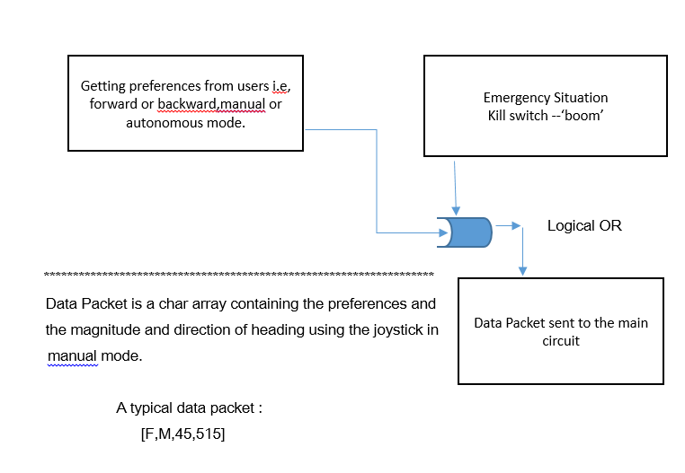The circuit schematic for the control box and the workflow block diagram is as shown below: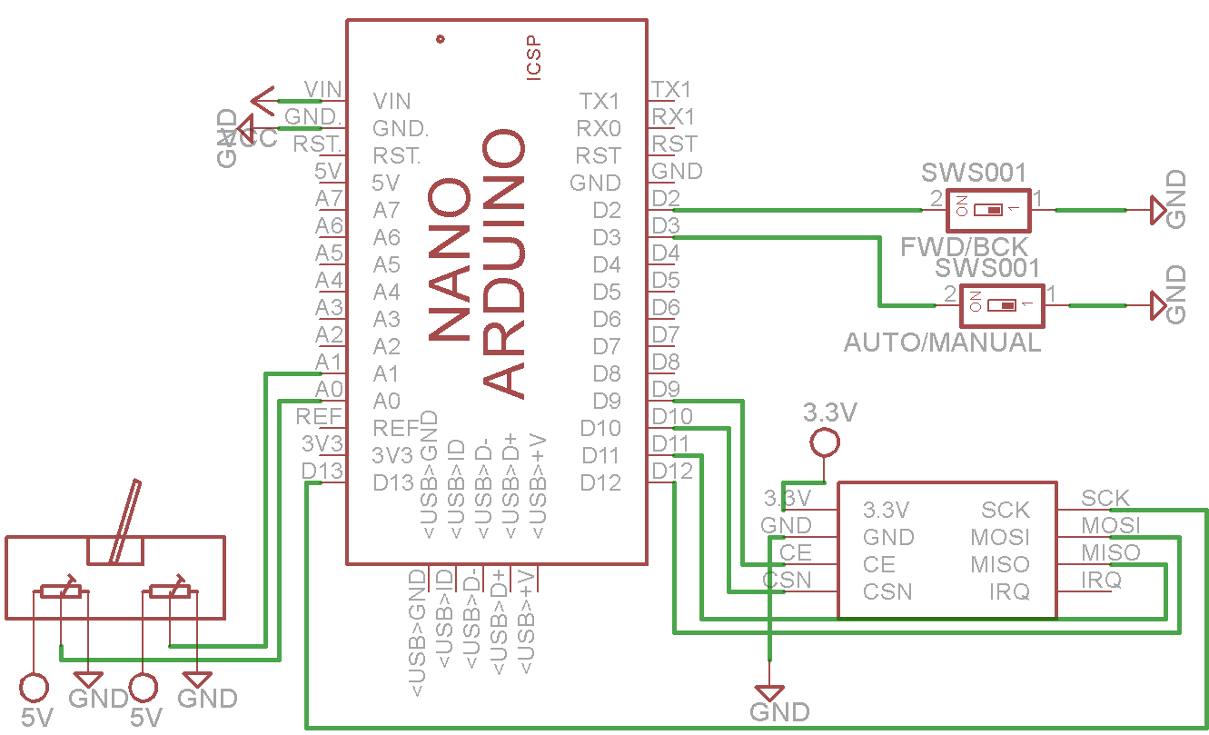

***Power Management***

The model is powered by two Lithium Polymer batteries.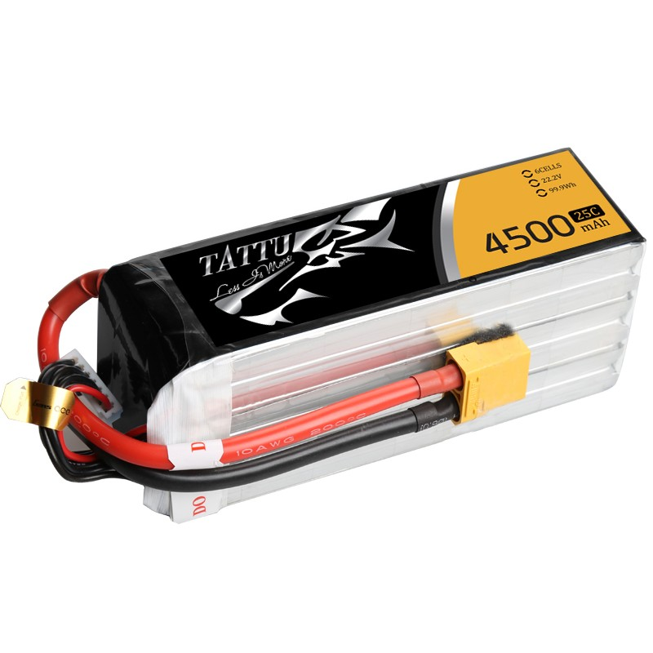

1. *22.2V, 4500mAh, 25C*
2. *11.1V, 3700mAh, 25C*

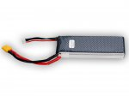

The power consumption analysis of the complete system is depicted in the table below.

|  |  |  |  |  |
| --- | --- | --- | --- | --- |
| **Component** | **Model No.** | **Current Rating** | **Operating voltage** | **Power** |
| 3-Sonars | HC-SR04 | 15mA | 5V | 75x3 = 225mW |
| Raspberry Pi 2 | - | 350mA | 5V | 1500mW |
| IMU | MPU6050 | 4mA | 5V | 20mW |
| DAC | PCF8591 | 20mA | 5V | 100mW |
| BLDC Motor | - | 10A | 24V | 240W |
| Steer motor | - | 7.5A | 12V | 90W |
| Brake Motor | - | 300mA | 12V | 3.6W |
| Arduino(IDLE) | - | 100mA | 5V | 500 mW |
| Wireless Receiver | NRF24L01+ | 15mA | 5V | 75 mW |

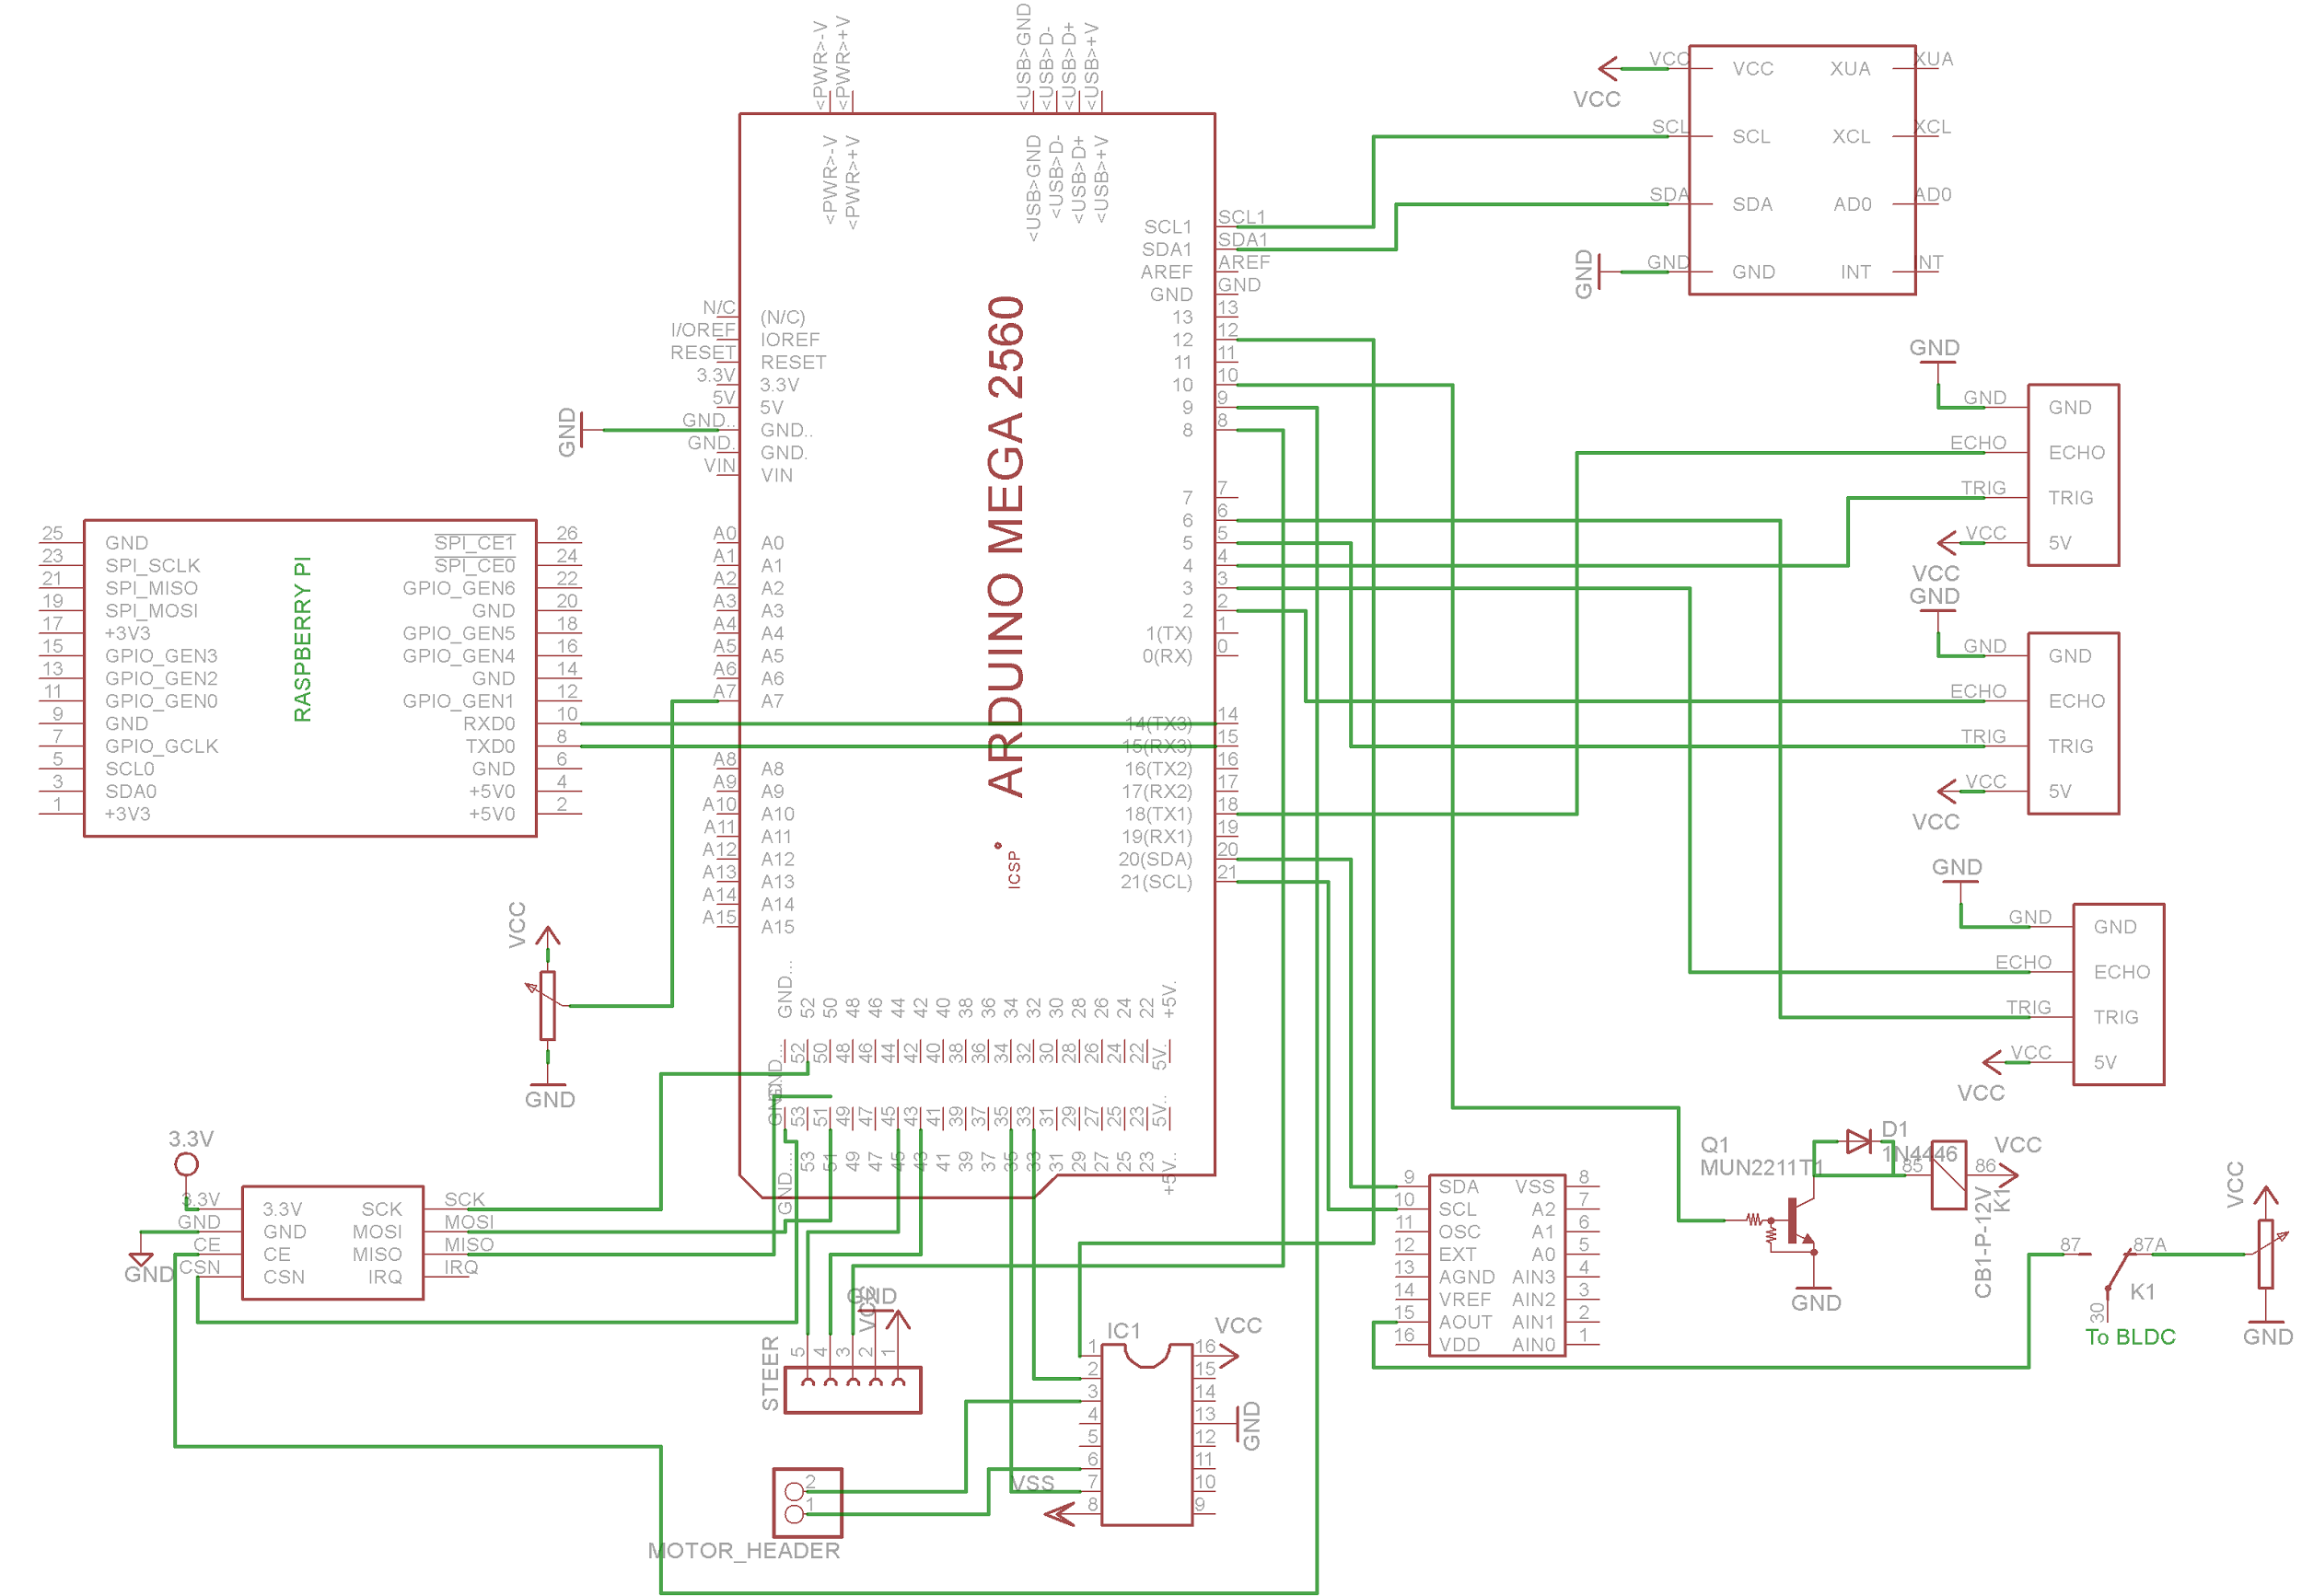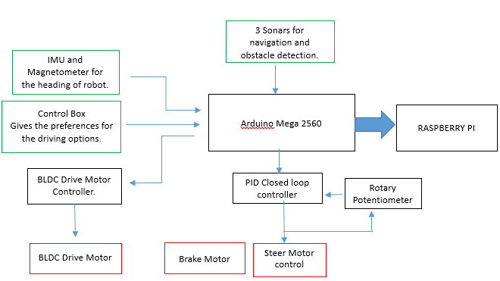***Complete Embedded Architecture and Circuit Schematic***

***Image Processing using OpenCV and ROS on Raspberry Pi***

For individuals suffering from disabilities, driverless vehicles could provide a level of freedom that was previously unobtainable. While previously people living with a disability may have had to rely on carers, family and public transport to get out and about on a daily basis, self-driving cars open up a new wealth of possibilities. An autonomous vehicle could allow a user to travel further to work, explore areas which aren't served by public transport and basically organize their own lives, whereas in the past this might not have been possible.

Since Raspberry Pi is capable of computer vision based control, the navigation of the model can be greatly aided by the application of certain image processing algorithms. The following were implemented using computer vision with ROS on the Pi.

***Lane Detection and Tracking***

The aim was to achieve the objective of lane detection and navigation using real time image processing and perspective transformation.

The problem was approached stepwise as following:

1. *Filter noise from image*

Since the input image contains a lot of noise, it was necessary to pre-process the image using noise filters. Gaussian and median filter gave good results. Other common approaches like erosion and dilution slowed processing without any significant improvements.

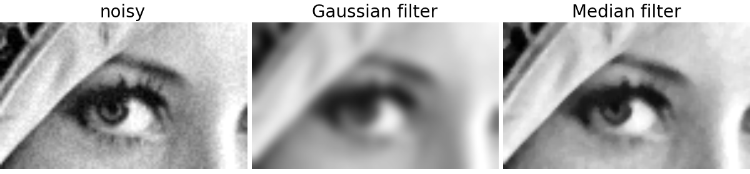

1. *Run Canny operator on the image:*

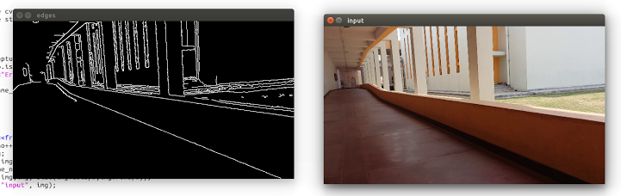After filtering out noise, we run the canny edge detector. The detector computes intensity gradients for the image and compresses non-maximum edges. A double threshold is applied to find potential edges.

1. *Hough line transformation and identifying lanes:*

Hough line transform is used identify lines by a voting procedure. The algorithm uses a two-dimensional array, called an accumulator, to detect the existence of a line described by:.

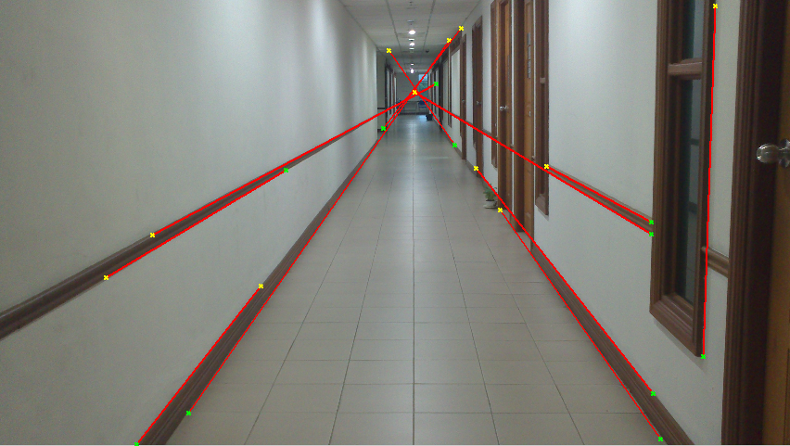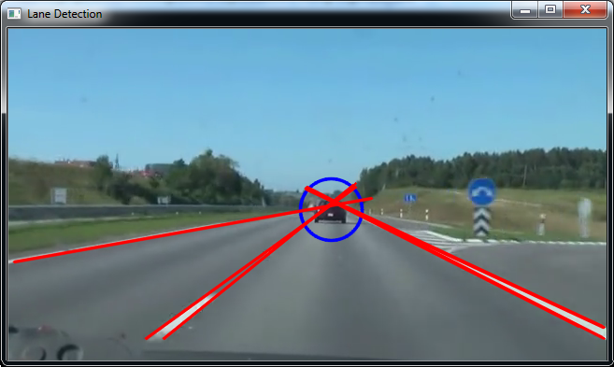 Lines with large enough consensus set are considered for further processing. The filter out pillars and other non-lane lines, the criterion used is: The right lane always intersects the lower-right boundary of the image and vice-versa for left lanes.

1. *Merging similar lines and Inverse perspective transformation:*

Generally there are a lot of lines corresponding to a single lane. An average line is computed for each lane using several restrictions on angle and intercepts. After this we have two basic lines corresponding to those lanes.

Now to localize our position in the lane we apply inverse perspective transformation. This gives us the birds eye view of the road so that we are able to locate the birds eye distance from both the lanes. This helps in building the mapping and navigation system.

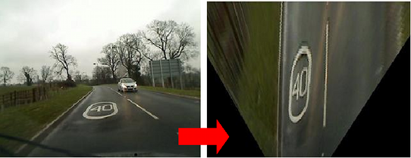

***Obstacle Detection***

Attempt was made to extract features, assign descriptor vectors and match them with standard templates to detect obstacles. Accurate descriptors like SIFT were too slow for real time implementation and faster versions like Surf and Orb weren’t reliable enough.

OpenCV provides a machine learning framework for training and using classifiers (Haar Cascade Classifier) for object identification. The classifier was used and the algorithm was trained using multiple images of standard obstacles. But the results weren’t accurate enough so as to be implemented on hardware.

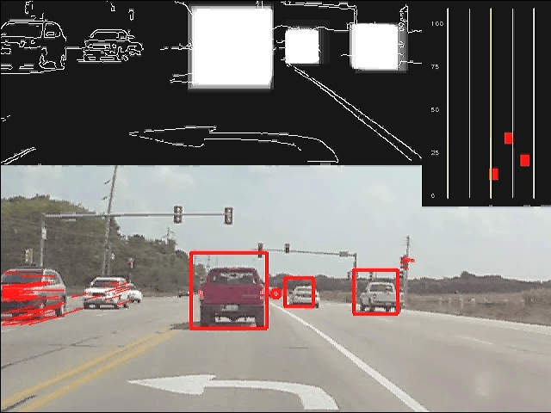

***Android Application for Offline Bluetooth Voice Control***

The app connects with Bluetooth adapter using RFCOMM protocol and provides commands using voice recognition.

The voice recognition is implemented offline for a pre-defined dictionary of words which determines the closest match between the detected voice signal and the stored words in the dictionary. The recognized word is then sent to the Embedded System on the model via Bluetooth. Offline recognition significantly improves the voice recognition speed.

User Interface of the app is as follows:

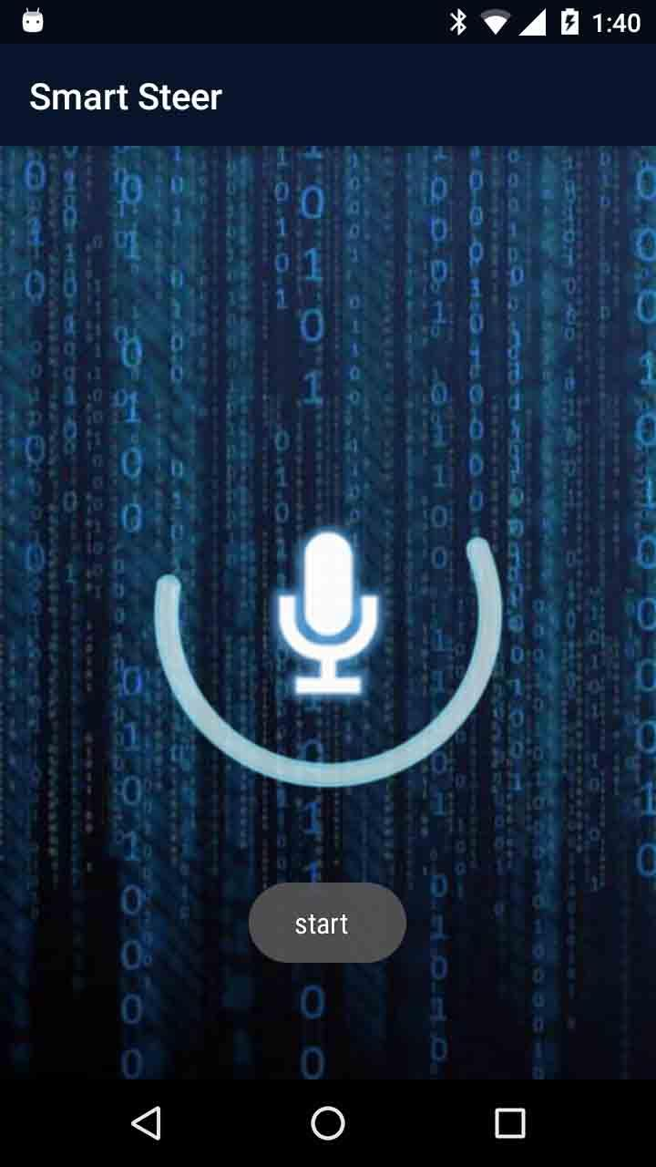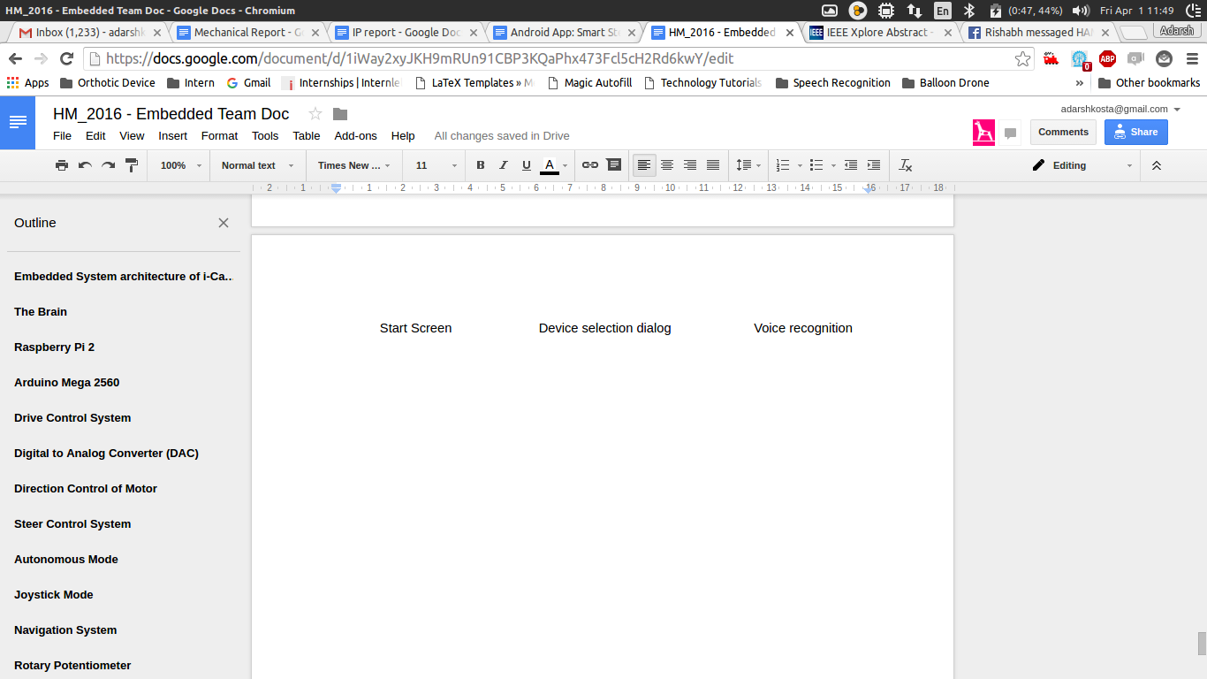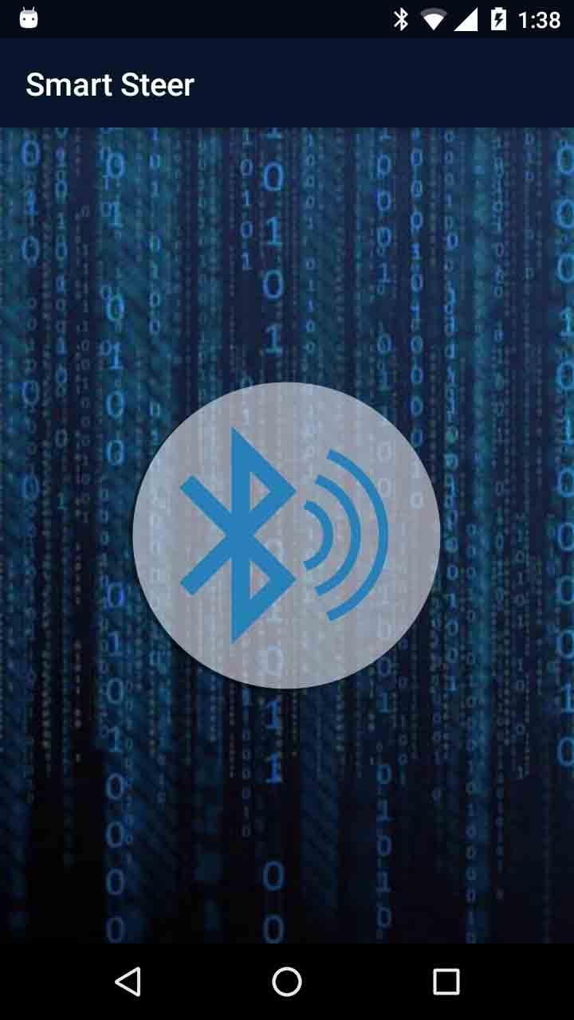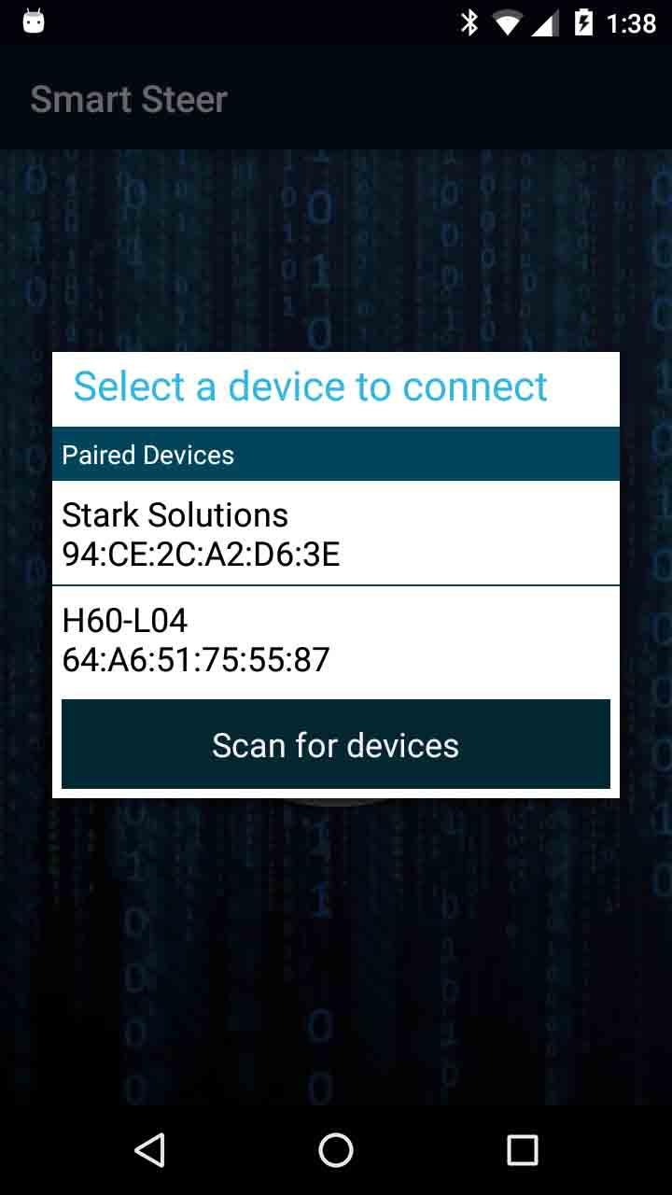

User is notified using Toast (a small popup) and a notification sound for every command sent via Bluetooth. App also runs in background to support voice recognition even when user is not using the app or the device’s screen is off.

***Cost Analysis***

|  |  |  |
| --- | --- | --- |
| **Component** | **Quantity** | **Price(INR)** |
| Raspberry Pi 2 | 1 | 2020 |
| Arduino Mega 2560 | 1 | 800 |
| Arduino Nano | 1 | 300 |
| BLDC motor + Controller Kit | 1 | 6000 |
| Joystick | 1 | 100 |
| High Torque DC motor | 1 | 4000 |
| High Current DC Motor driver | 1 | 650 |
| Potentiometer | 1 | 250 |
| DC motor (200 RPM) + L293d | 1 | 200 |
| IMU(MPU6050) | 1 | 200 |
| Magnetometer(HMC5888L) | 1 | 200 |
| Sonars(HC-SR04) | 3 | 150x3 = 350 |
| NRF24L01+ | 2 | 80x2 = 160 |
| DAC module | 1 | 230 |
| 22.2V Battery | 1 | 5600 |
| 11.1V Battery | 1 | 2900 |
| Logitech Webcam | 1 | 1100 |
| Mechanical Parts and Manufacturing | - | 5000 |
| **TOTAL** |  | Rs 30060 |